1. Peiyun(Seed) Zeng. Jing Lu

2 and 3

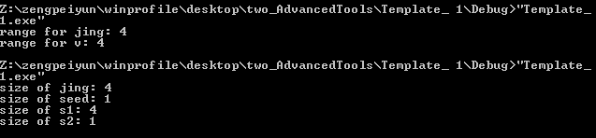

Q2: both array and vector have 4 elements, so count() method returns 4

Q3: The struct has the same size as the parameterized member variable

4.

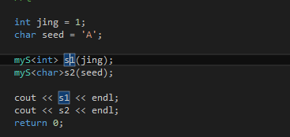

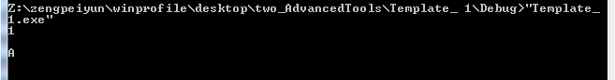

Results show that << operator streams the value of the member variable of an object whatever the type is

5.

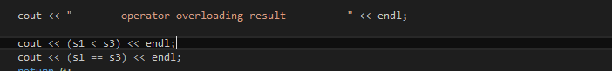

output



6.

1. Copy and assignment operator works correctly since we specified the type of the object when declare
2. Program gives error because there is no default constructor
3. When using templates, it is not possible to determine the type of default values because template can be anything
4. Not a good idea because we don’t know how to initialize the values(i.e. template can be anything)